**Basic Pratice of Programming Meeting 1**



**From:**

AL AZHAR RIZQI RIFA’I FIRDAUS

**Class:**

1 I

**Absence:**

01

**Major:**

Information Technology

**Study Program:**

Informatic Engineering

**Experiment 1: Installing the Java Development Kit/JDK**

Screenshoot java binary at file bin

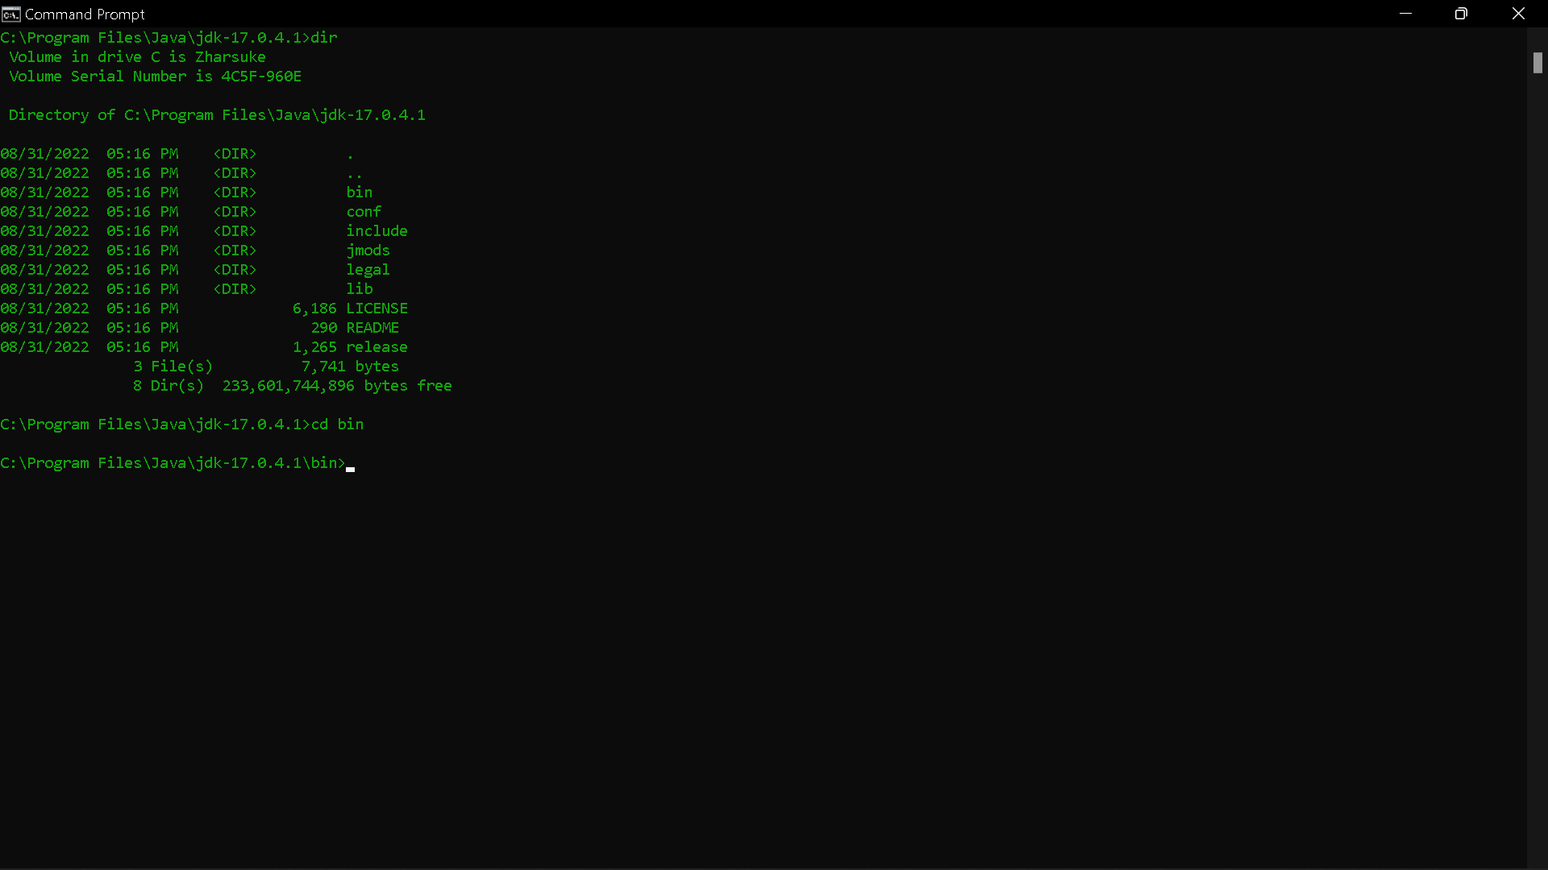

Screenshoot path env location

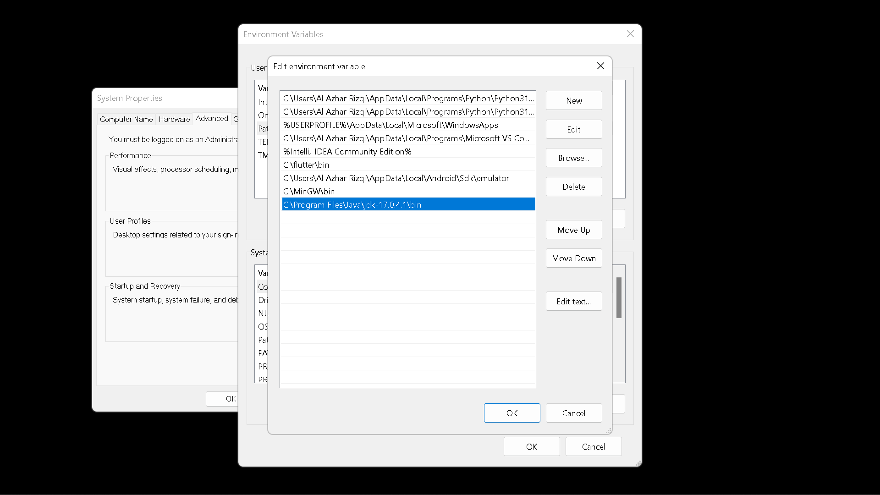

Screenshoot running javac

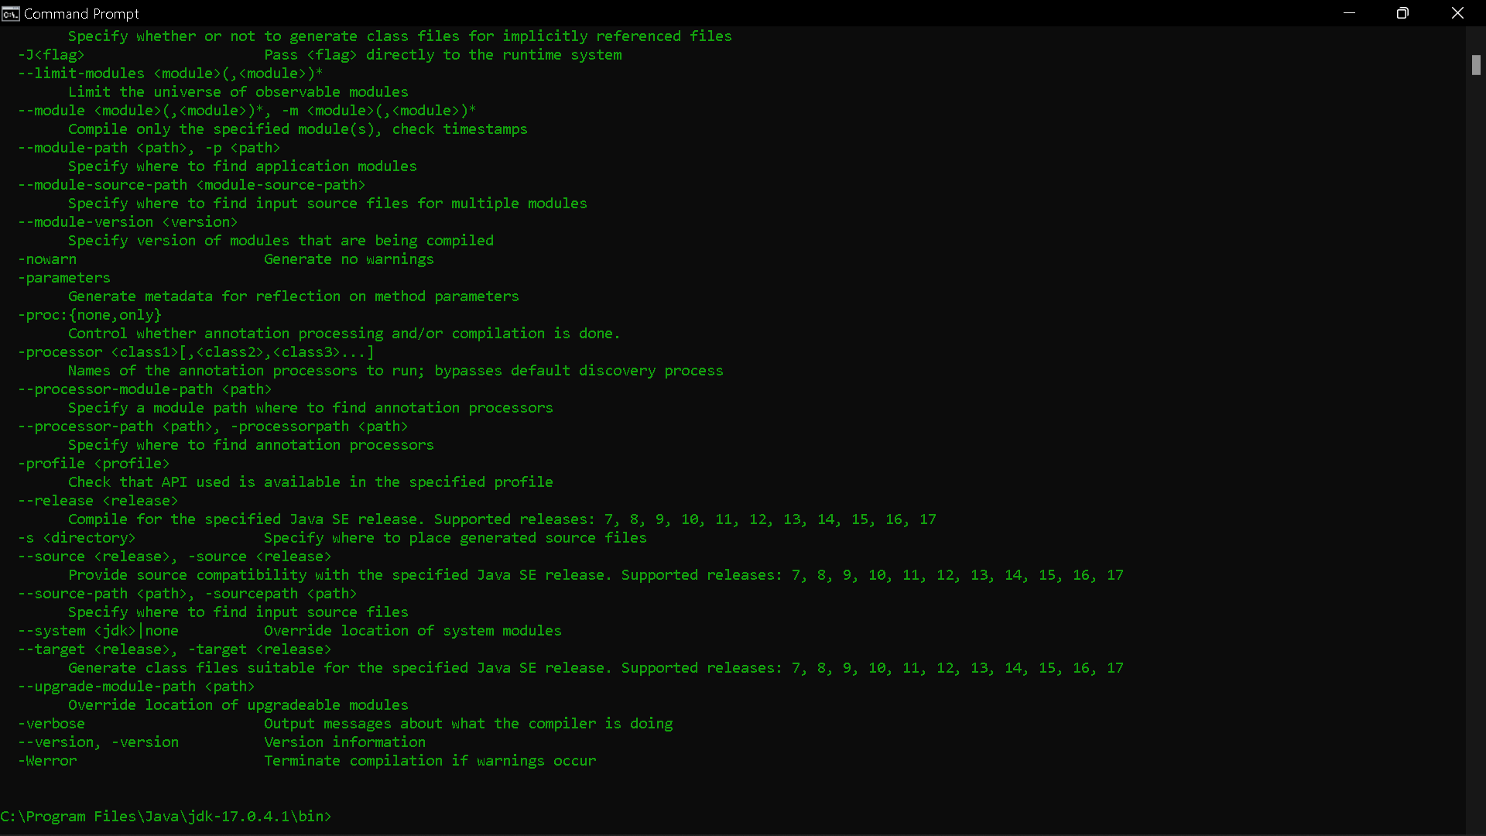

**Questions**

1. Explain the use of entering the location of the Java bin folder into the PATH!

2. Explain the use of the javac command when entering the command prompt!

**Answer**

1. To put the directories who want to search when do command at command prompt.
2. Javac is one of binary file at jdk to compile file .java to .class file which one will be execute again with “java” command.

**Experiment 2: Basic Structure of Java**

Screenshoot file MyFirstJava00.java

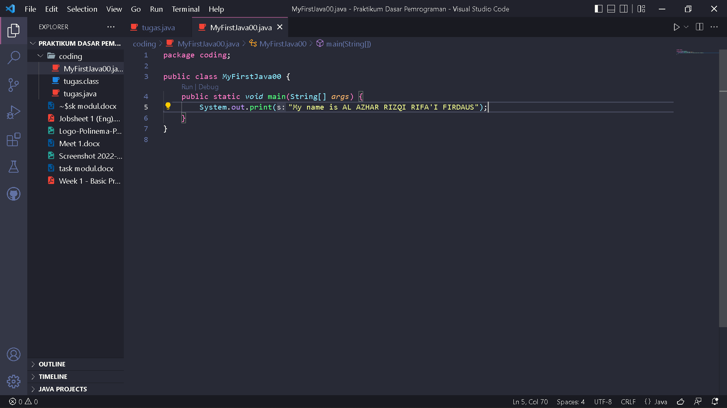

Screenshoot output file MyFirstJava00.java

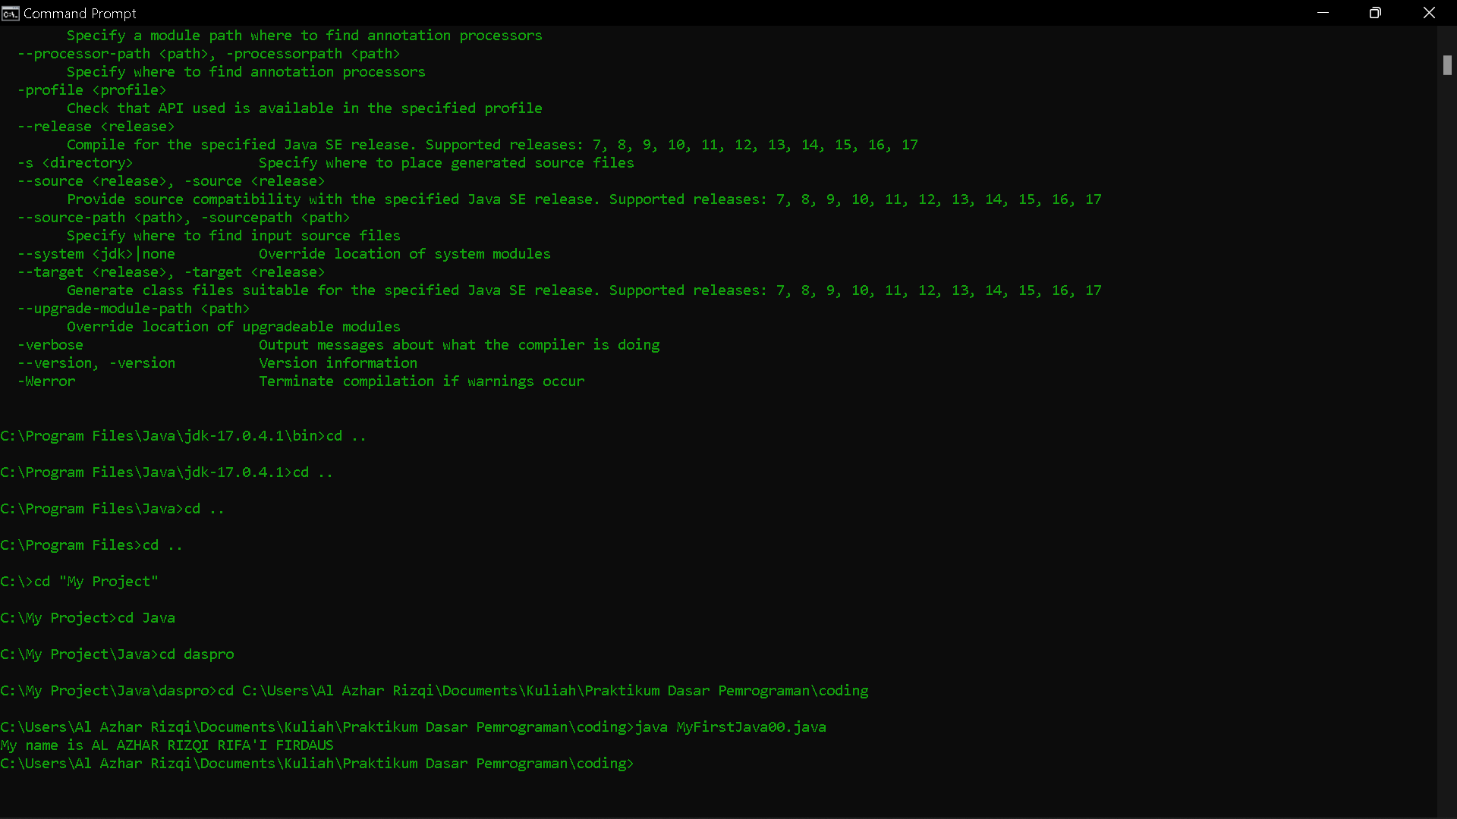

**Questions!**

1. Explain the function of javac MyFirstJava00.java command in the experiment!

2. Explain the function of java MyFirstJava00 command in the experiment!

3. Add the program code System.out.println("I am a Student of Informatics Engineering Program"); on line 6, then run the program and explain how the output is!

Code :

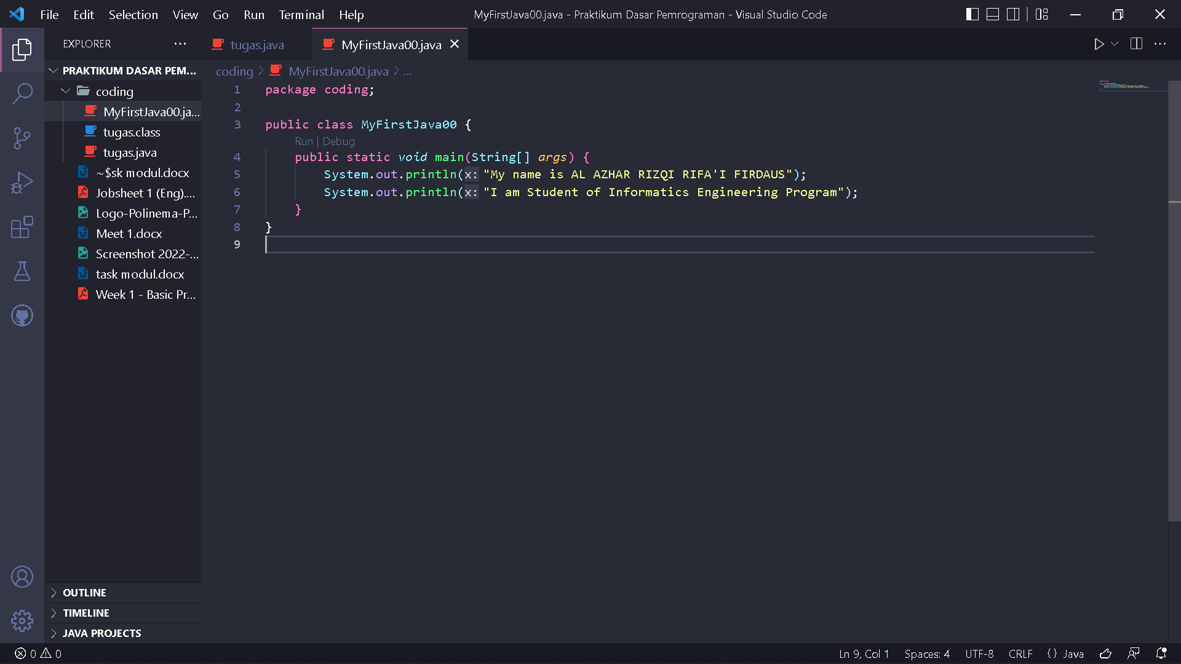

Output :

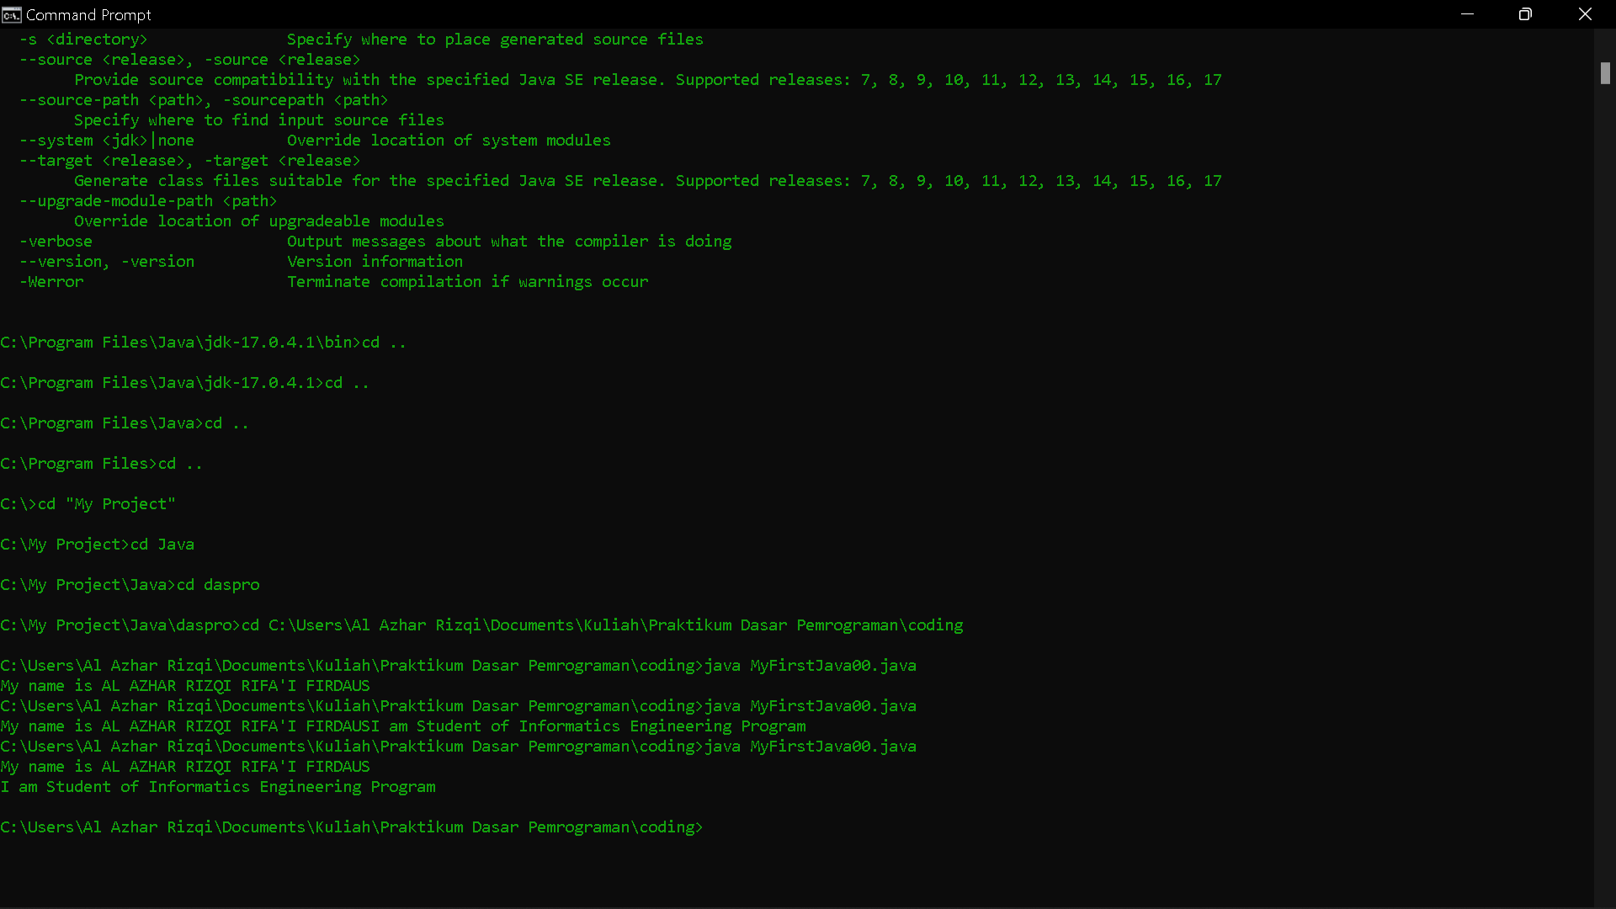

**Explanation**

With add statement :

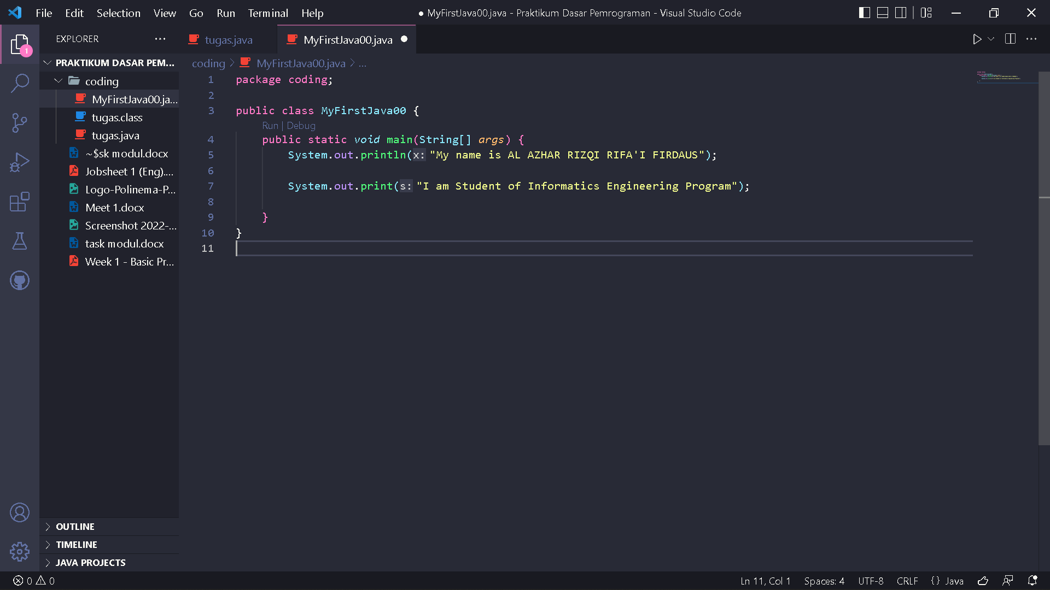

Output will display “I am Student of Informatics Engineering Program”

4.Code :

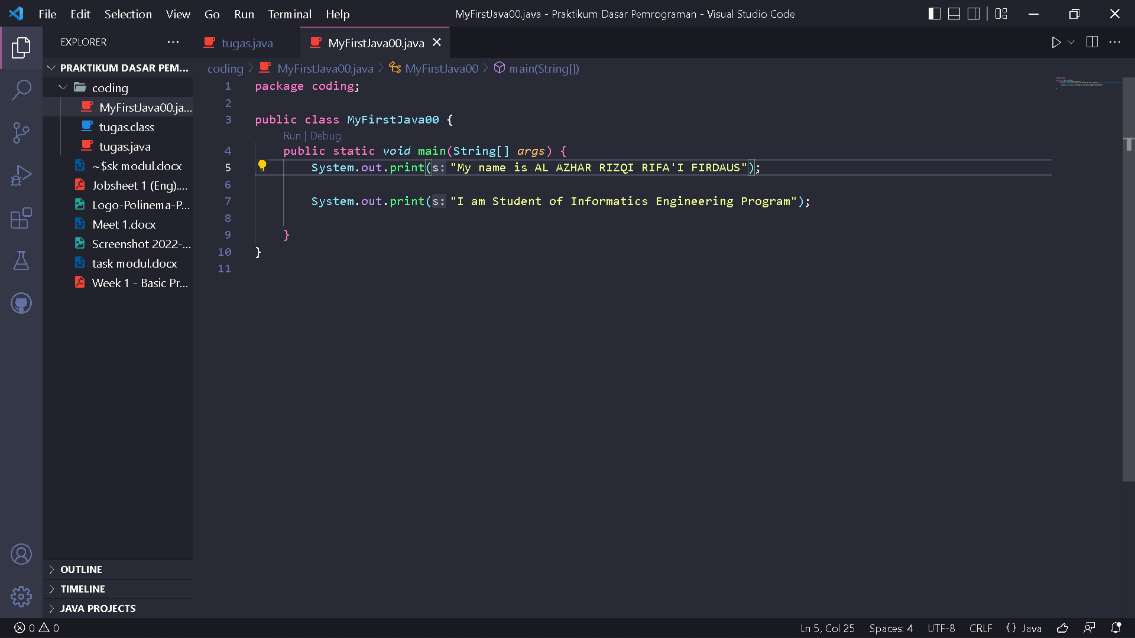

Output :

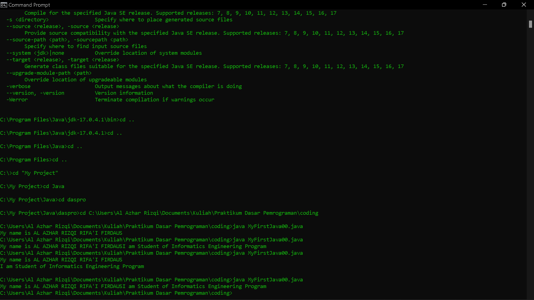

5. The difference between

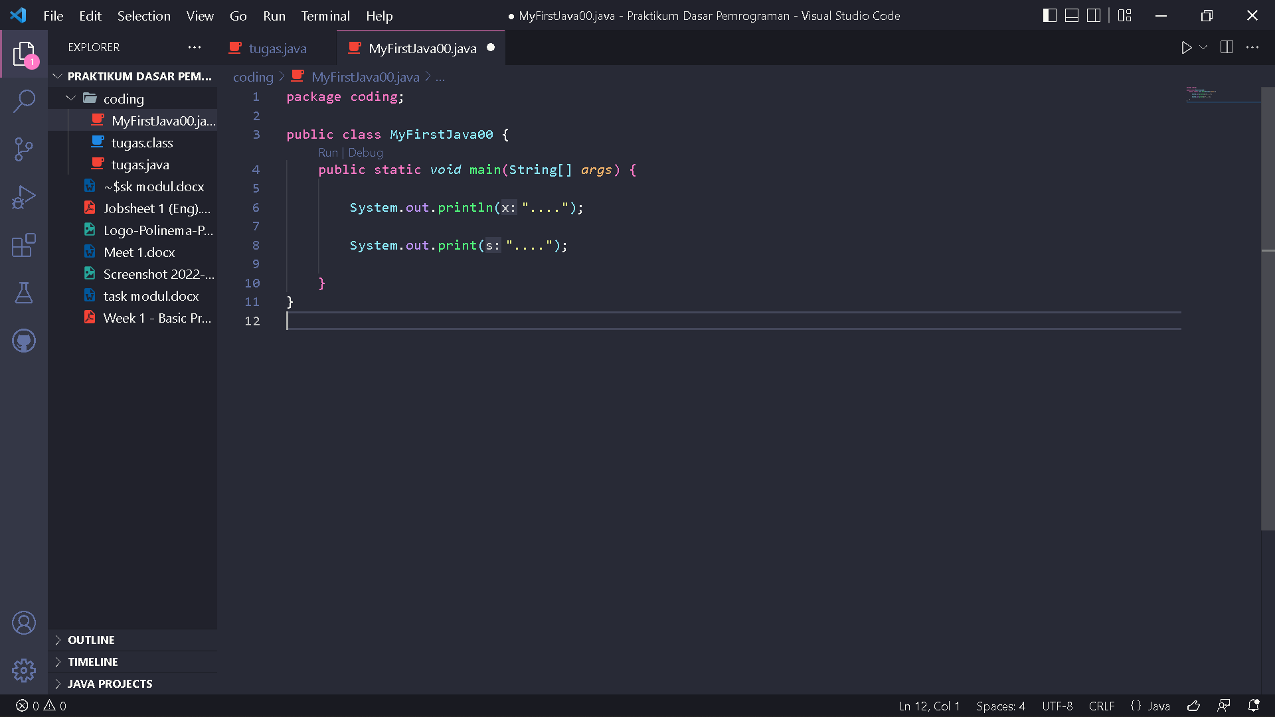

With



Is on adding enter to the output where ‘println’ add enter at the end of its output and ‘print’ does not.

6. Code :

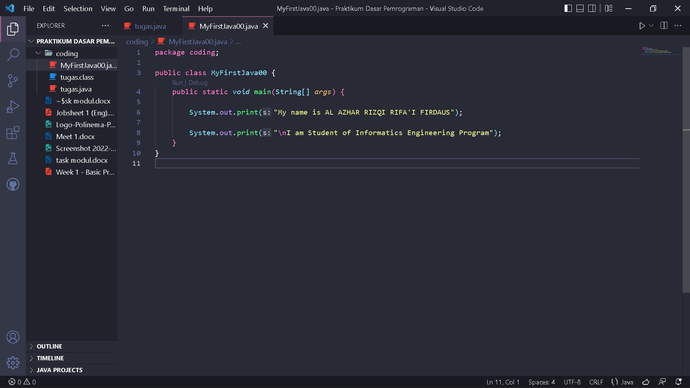

7. The function symbol \n to add enter newline at output.

8. Code :

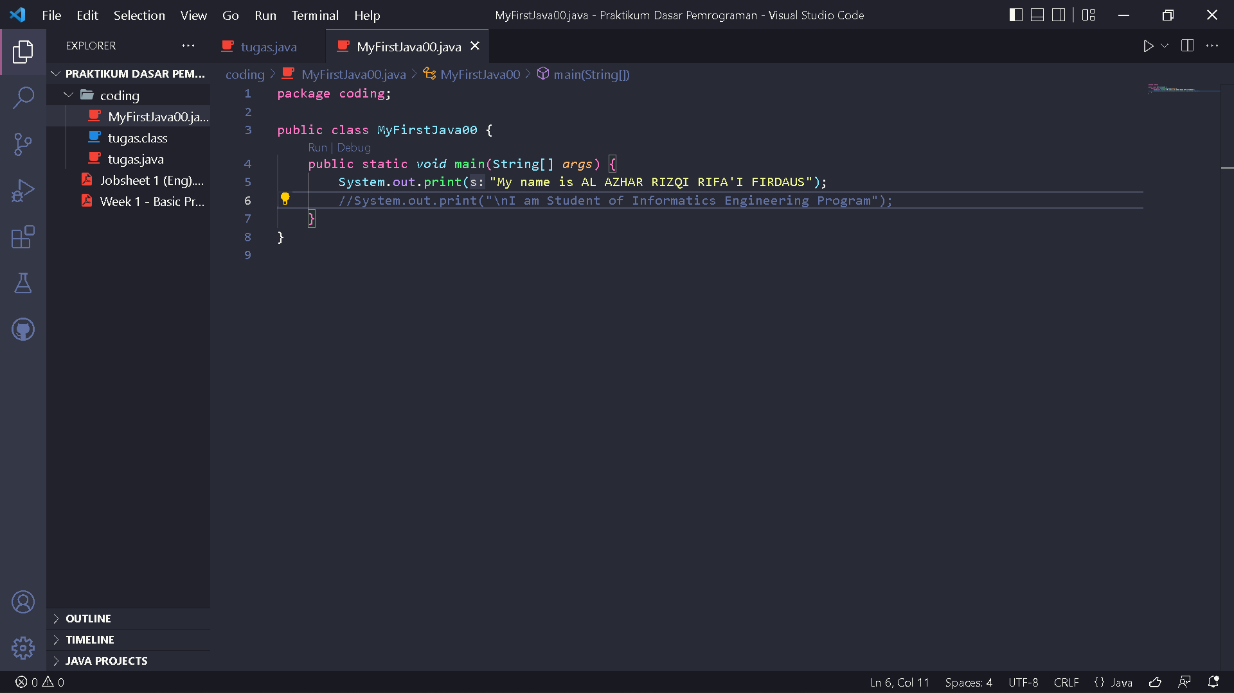

9. Program observation

10. The function from // symbol to give comment at code useful to give description with human language at code too much and too complicated.

**Assignment**

Code :

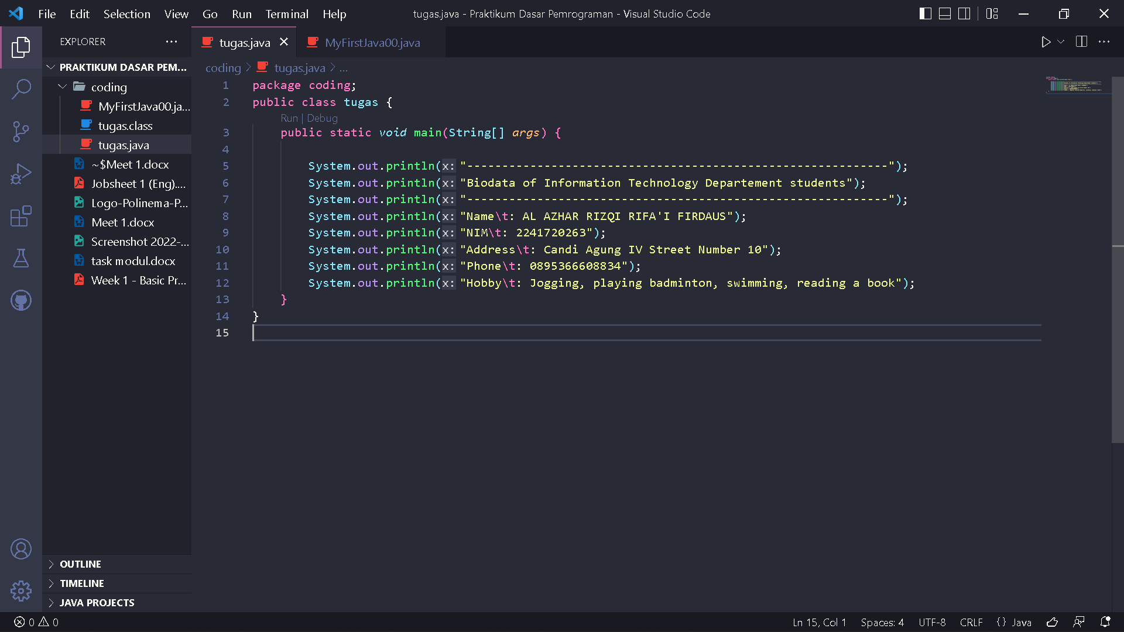

Output :

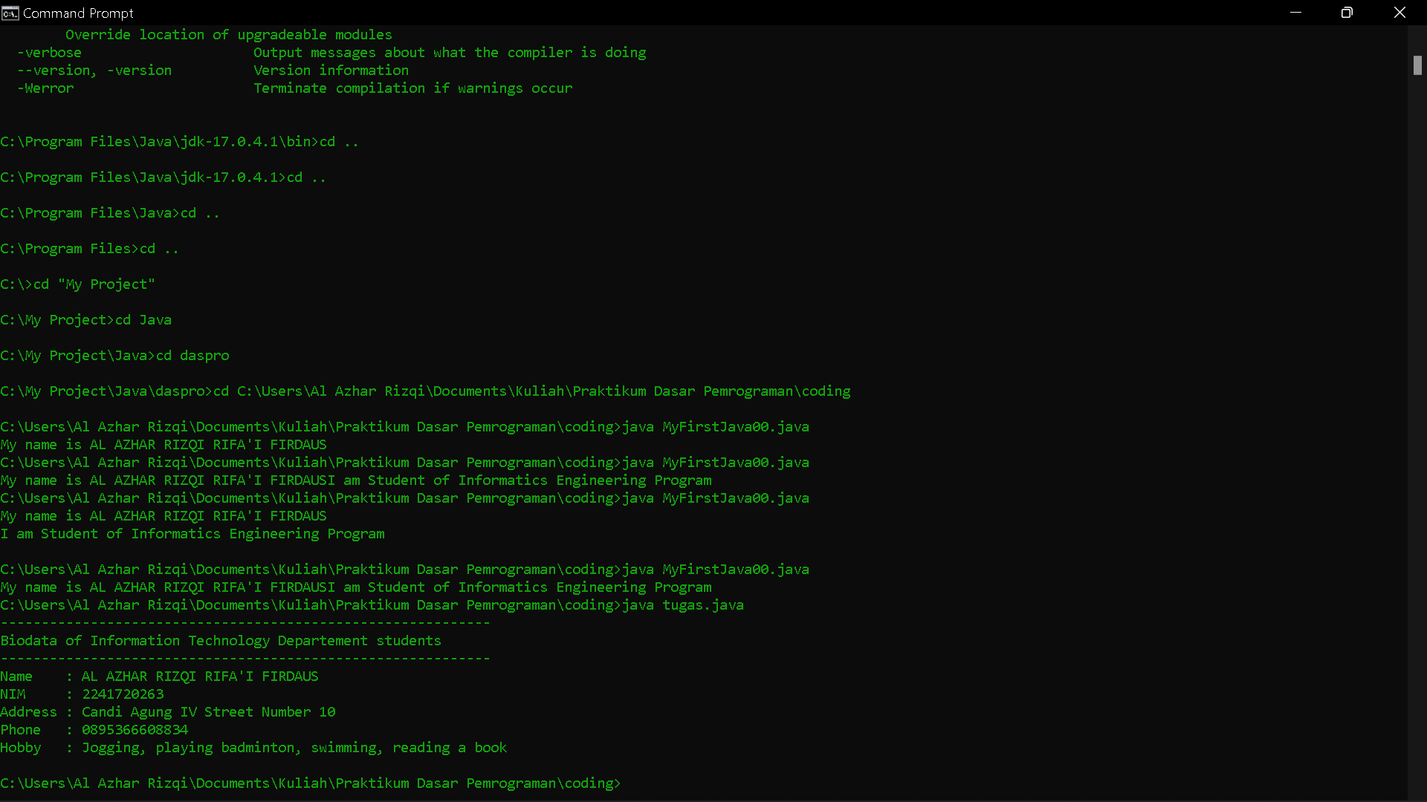

Explanation :

The above program aims to display output in the form of your own identity, which uses the statement System.out.println() as a means of outputting the terminal.